Ques1

-- Create the table

CREATE TABLE tbl_happiness (

SNo INT,

Rankings INT,

Country VARCHAR(100)

);

-- Insert data into the table

INSERT INTO tbl_happiness (SNo, Rankings, Country) VALUES (1, 1, 'Finland');

INSERT INTO tbl_happiness (SNo, Rankings, Country) VALUES (2, 2, 'Denmark');

INSERT INTO tbl_happiness (SNo, Rankings, Country) VALUES (3, 3, 'Iceland');

INSERT INTO tbl_happiness (SNo, Rankings, Country) VALUES (4, 4, 'Israel');

INSERT INTO tbl_happiness (SNo, Rankings, Country) VALUES (5, 5, 'Netherlands');

INSERT INTO tbl_happiness (SNo, Rankings, Country) VALUES (6, 6, 'Sweden');

INSERT INTO tbl_happiness (SNo, Rankings, Country) VALUES (7, 7, 'Norway');

INSERT INTO tbl_happiness (SNo, Rankings, Country) VALUES (8, 126, 'India');

INSERT INTO tbl_happiness (SNo, Rankings, Country) VALUES (9, 128, 'Sri Lanka');

Ques 2:

-- Create the table

CREATE TABLE TriangleSegments (

x INT,

y INT,

z INT

);

select * from TriangleSegments

-- Insert the data

INSERT INTO TriangleSegments (x, y, z) VALUES (13, 15, 30);

INSERT INTO TriangleSegments (x, y, z) VALUES (10, 20, 15);

Ques 3:

-- Create the table

CREATE TABLE Emp (

Emp_Id INT

);

-- Insert the data

INSERT INTO Emp (Emp_Id) VALUES (2);

INSERT INTO Emp (Emp_Id) VALUES (5);

INSERT INTO Emp (Emp_Id) VALUES (6);

INSERT INTO Emp (Emp_Id) VALUES (6);

INSERT INTO Emp (Emp_Id) VALUES (7);

INSERT INTO Emp (Emp_Id) VALUES (8);

INSERT INTO Emp (Emp_Id) VALUES (8);

Ques 4:

-- Create the table

CREATE DATABASE DAY2

USE DAY2

CREATE TABLE employee (

Emp_Id INT PRIMARY KEY,

Emp_Name VARCHAR(50),

Emp_Salary INT

);

-- Insert data

INSERT INTO employee (Emp_Id, Emp_Name, Emp_Salary) VALUES

(1, 'Alice', 4000),

(2, 'Bob', 6000),

(3, 'Charlie', 2000),

(4, 'David', 8000),

(5,'akash',8000),

(6,'ajay',6000);

Ques(5)

create database q3

use q3

CREATE TABLE Friends1 (

p1_id INT,

p2_id INT

);

INSERT INTO Friends1 (p1_id, p2_id) VALUES

(1, 2),

(1, 3),

(2, 3),

(3, 4);

Ques 6

-- Create Table2

CREATE TABLE Employees2 (

p1_id INT,

p2_id INT

);

-- Insert data into Table2

INSERT INTO Employees2(p1_id, p2_id) VALUES

(1, 2),

(1, 3);

use q5

CREATE TABLE MultiValued (

COL1 INT,

COL2 VARCHAR(100)

);

INSERT INTO MultiValued (COL1, COL2) VALUES

(1, 'A,B,C'),

(2, 'A,B');

INSERT INTO MultiValued (COL1, COL2) VALUES

(3,'A,BC,D')

**Q7**

CREATE TABLE insurance (

pid INT PRIMARY KEY,

tiv_2015 FLOAT,

tiv_2016 FLOAT,

lat FLOAT,

lon FLOAT

);

-- Insert data

INSERT INTO insurance (pid, tiv_2015, tiv_2016, lat, lon)

VALUES

(1, 10, 5, 10, 10),

(2, 20, 20, 20, 20),

(3, 10, 30, 20, 20),

(4, 10, 40, 40, 40),

(5, 30, 15, 25, 25),

(6, 30, 5, 35, 35);

create database q6

use q6

-- Create the Employees table

CREATE TABLE Employees (

EMP_ID INT PRIMARY KEY,

EMAIL VARCHAR(100)

);

-- Insert data

INSERT INTO Employees (EMP_ID, EMAIL)

VALUES

(1, 'AMAN@GMAIL.COM'),

(2, 'SHREYA@OUTLOOK.COM'),

(3, 'PIYUSH@HOTMAIL.COM');

**Ques 8**

-- Create the Employees table

CREATE TABLE Employees (

EMP_ID INT PRIMARY KEY,

EMAIL VARCHAR(100)

);

-- Insert data

INSERT INTO Employees (EMP_ID, EMAIL)

VALUES

(1, 'AMAN@GMAIL.COM'),

(2, 'SHREYA@OUTLOOK.COM'),

(3, 'PIYUSH@HOTMAIL.COM');

**Q9**

-- Create Thief_1_2016 table

CREATE TABLE Thief_1_2016 (

id INT PRIMARY KEY,

name VARCHAR(50)

);

-- Insert data into Thief_1_2016

INSERT INTO Thief_1_2016 (id, name) VALUES

(1, 'Sumit'),

(2, 'Nisha'),

(3, 'Akash');

-- Create Thief_2_2017 table

CREATE TABLE Thief_2_2017 (

id INT PRIMARY KEY,

name VARCHAR(50)

);

-- Insert data into Thief_2_2017

INSERT INTO Thief_2_2017 (id, name) VALUES

(2, 'Nisha'),

(4, 'Charlie');

**Week 2**

**Q 1:**

**We have an table Movies,Users,Movie Rating**

**Write a solution to:**

**•Find the name of the user who has rated the greatest number of movies. In case of a tie, return the lexicographically smaller user name.**

**•Find the movie name with the highest average rating in February 2020. In case of a tie, return the lexicographically smaller movie name.**

**Write a solution to:**

**•Find the name of the user who has rated the greatest number of movies. In case of a tie, return the lexicographically smaller user name.**

**•Find the movie name with the highest average rating in February 2020. In case of a tie, return the lexicographically smaller movie name.**

create database week3_imp

use week3_imp

-- Create Movies Table

CREATE TABLE Movies (

movie_id INT PRIMARY KEY,

title VARCHAR(100)

);

-- Create Users Table

CREATE TABLE Users (

user_id INT PRIMARY KEY,

name VARCHAR(100)

);

CREATE TABLE MovieRating (

movie_id INT,

user_id INT,

rating INT,

created_at DATE,

FOREIGN KEY (movie_id) REFERENCES Movies(movie_id),

FOREIGN KEY (user_id) REFERENCES Users(user_id)

);

-- Insert data into Movies table

INSERT INTO Movies (movie_id, title)

VALUES

(1, 'Avengers'),

(2, 'Frozen 2'),

(3, 'Joker');

-- Insert data into Users table

INSERT INTO Users (user_id, name)

VALUES

(1, 'Daniel'),

(2, 'Monica'),

(3, 'Maria'),

(4, 'James');

truncate table users

INSERT INTO MovieRating (movie_id, user_id, rating, created_at)

VALUES

(1, 1, 3, '2020-01-12'),

(1, 2, 4, '2020-02-11'),

(1, 3, 2, '2020-02-12'),

(1, 4, 1, '2020-01-01'),

(2, 1, 5, '2020-02-17'),

(2, 2, 2, '2020-02-01'),

(2, 3, 2, '2020-03-01'),

(3, 1, 3, '2020-02-22'),

(3, 2, 4, '2020-02-25');

**Q 2:**

Given the Employees and Department tables having certain attributes in them . The task is to return the department name, Employee Name ,highest salary of the employees according to their departments.

create database week_2

use week_2

-- Department Table

CREATE TABLE Department (

ID INT PRIMARY KEY,

DEPT_NAME VARCHAR(50)

);

-- Employee Table

CREATE TABLE Employee (

ID INT,

NAME VARCHAR(50),

SALARY INT,

DEPT_ID INT,

FOREIGN KEY (DEPT_ID) REFERENCES Department(ID)

);

-- Insert into Department table

INSERT INTO Department (ID, DEPT_NAME) VALUES

(1, 'IT'),

(2, 'SALES');

-- Insert into Employee table

INSERT INTO Employee (ID, NAME, SALARY, DEPT_ID) VALUES

(1, 'JOE', 70000, 1),

(2, 'JIM', 90000, 1),

(3, 'HENRY', 80000, 2),

(4, 'SAM', 60000, 2),

(5, 'MAX', 90000, 1);

**Q:3**

USE week22

CREATE TABLE Activity (

player_id INT,

device_id INT,

event_date DATE,

games_played INT

);

INSERT INTO Activity (player_id, device_id, event_date, games_played) VALUES

(1, 2, '2016-03-01', 5),

(1, 2, '2016-03-02', 6),

(2, 3, '2017-06-25', 1),

(3, 1, '2016-03-02', 0),

(3, 4, '2018-07-03', 5);

**Ques 4:**

create database q5_5

use q5_5

6

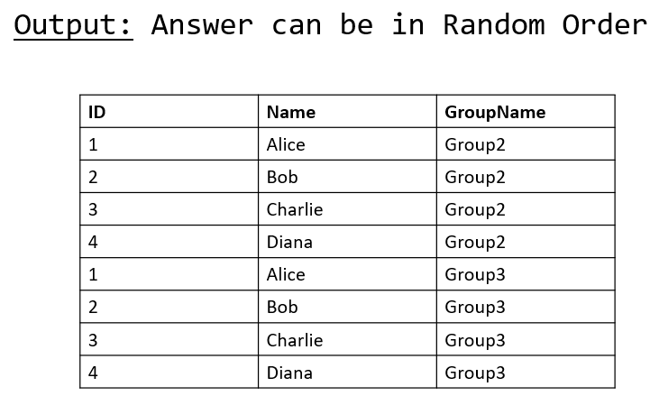

**Ques 5:**

USE week22

-- Create Prices table

CREATE TABLE Prices (

Product_id INT,

Start_date DATE,

End_date DATE,

Price INT

);

-- Insert data into Prices

INSERT INTO Prices (Product_id, Start_date, End_date, Price) VALUES

(1, '2019-02-17', '2019-02-28', 5),

(1, '2019-03-01', '2019-03-22', 20),

(2, '2019-02-01', '2019-02-20', 15),

(2, '2019-02-21', '2019-03-31', 30),

(3,'2024-01-21','2024-02-10',20);

truncate table prices

-- Create UnitSold table

CREATE TABLE UnitSold (

Product_id INT,

Purchase_date DATE,

Units INT

);

-- Insert data into UnitSold

INSERT INTO UnitSold (Product_id, Purchase_date, Units) VALUES

(1, '2019-02-25', 100),

(1, '2019-03-01', 15),

(2, '2019-02-10', 200),

(2, '2019-03-22', 30);

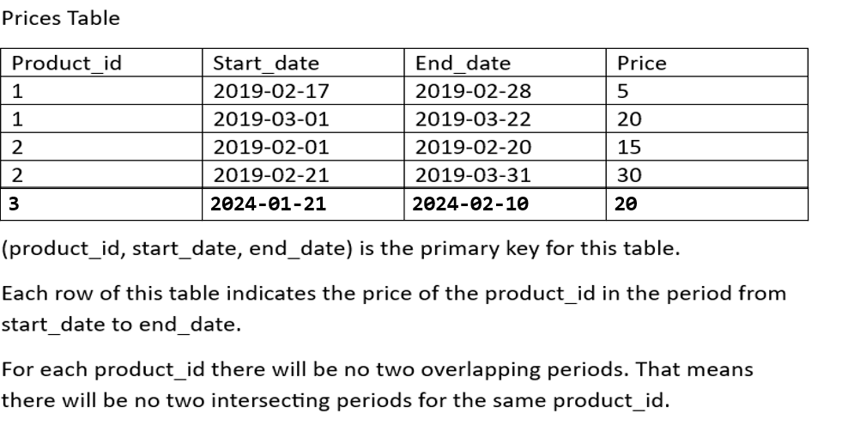

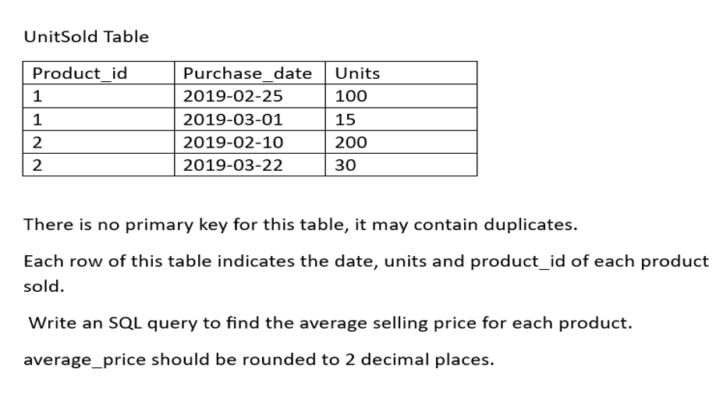

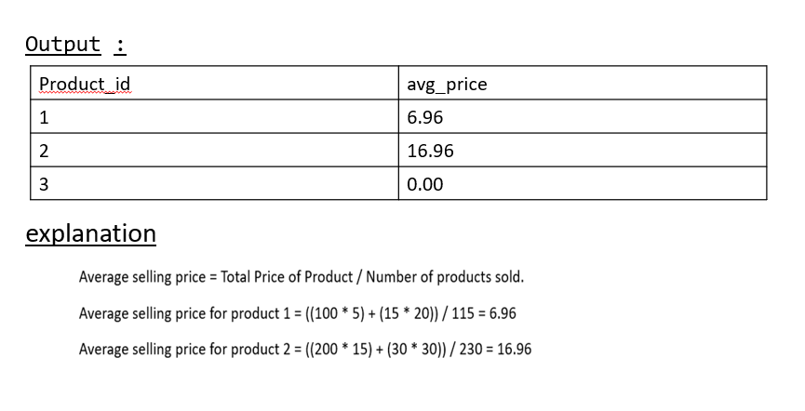

(6)

create database days2

use days2

CREATE TABLE UserProfile (

user_ID INT PRIMARY KEY,

Name VARCHAR(50),

Age INT,

Email VARCHAR(100)

);

INSERT INTO UserProfile (user_ID, Name, Age, Email) VALUES

(1, 'Rajesh', 28, 'rajesh@gmail.com'),

(2, 'Priya', 25, 'priya@gmail.com'),

(3, 'Suresh', 30, 'rajesh@gmail.com'),

(4, 'Anjali', 24, 'priya@gmail.com');

**Windows**

**(i)**

**create database week_2**

**use week_2**

-- Create table

CREATE TABLE Employee1 (

ID INT,

NAME VARCHAR(50),

SALARY INT,

DEPT_NAME VARCHAR(20),

JOINING_DATE DATE

);

**-- Insert records with random JOINING_DATE values**

INSERT INTO Employee1 VALUES (1, 'AKASH', 25000, 'IT', '2021-05-14');

INSERT INTO Employee1 VALUES (2, 'VIKAS', 5000, 'SALES', '2022-08-01');

INSERT INTO Employee1 VALUES (3, 'ANAY', 5000, 'IT', '2020-11-23');

INSERT INTO Employee1 VALUES (4, 'ADITYA', 51000, 'SALES', '2023-03-10');

INSERT INTO Employee1 VALUES (5, 'RAVI', 6000, 'IT', '2021-09-17');

INSERT INTO Employee1 VALUES (6, 'ANUJ', 7000, 'SALES', '2020-07-05');

INSERT INTO Employee1 VALUES (7, 'DEEP', 21000, 'IT', '2022-02-25');

INSERT INTO Employee1 VALUES (8, 'NISHA', 52000, 'SALES', '2023-12-19');

INSERT INTO Employee1 VALUES (9, 'KARAN', 18000, 'HR', '2022-06-08');

INSERT INTO Employee1 VALUES (10, 'SNEHA', 35000, 'IT', '2023-01-12');

INSERT INTO Employee1 VALUES (11, 'MOHIT', 27000, 'MARKETING', '2021-03-19');

INSERT INTO Employee1 VALUES (12, 'RIYA', 40000, 'HR', '2020-10-28');

INSERT INTO Employee1 VALUES (13, 'AMAN', 15000, 'MARKETING', '2022-11-05')**;**

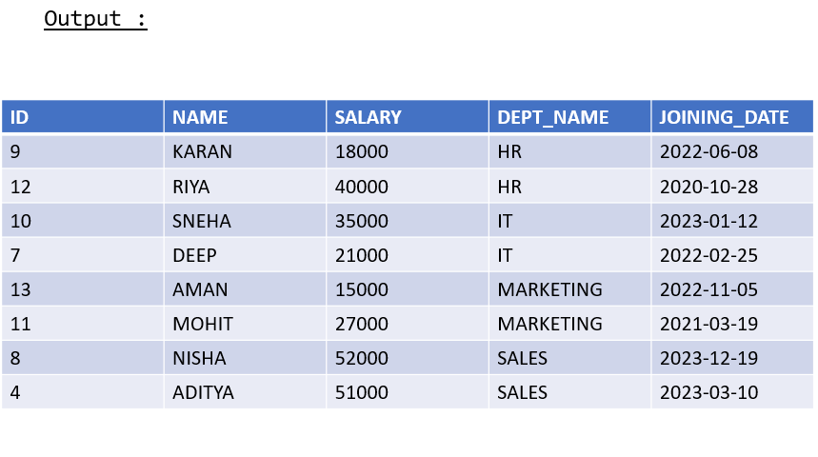

(ii)

-- Create the Sales table

CREATE TABLE Sales (

customer_id INT,

name VARCHAR(50),

visited_on DATE,

amount INT

);

-- Insert data into Sales table

INSERT INTO Sales (customer_id, name, visited_on, amount) VALUES

(1, 'Jhon', '2019-01-01', 100),

(2, 'Daniel', '2019-01-02', 110),

(3, 'Jade', '2019-01-03', 120),

(4, 'Khaled', '2019-01-04', 130),

(5, 'Winston', '2019-01-05', 110),

(6, 'Elvis', '2019-01-06', 140),

(7, 'Anna', '2019-01-07', 150),

(8, 'Maria', '2019-01-08', 80),

(9, 'Jaze', '2019-01-09', 110);

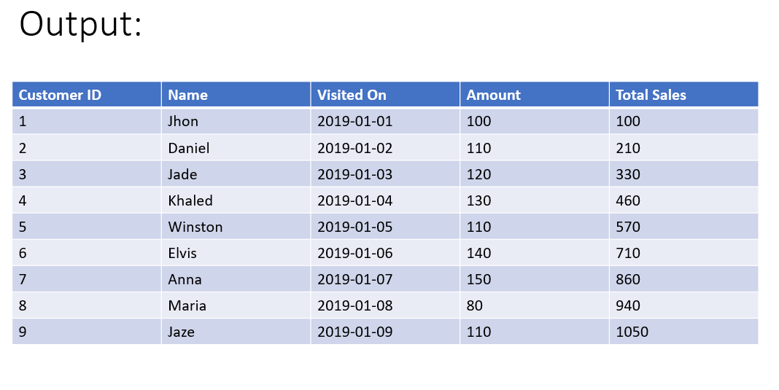

(iii)

CREATE TABLE Orders (

ID INT PRIMARY KEY,

Name VARCHAR(50),

Amount INT,

OrderDate DATETIME

);

INSERT INTO Orders (ID, Name, Amount, OrderDate) VALUES

(1, 'SHALABH', 2200, '2025-04-24 00:26:46.190'), ---190 mili second

(2, 'SHALABH', 2400, '2025-04-24 00:27:04.760'),

(3, 'SHALABH', 400, '2025-04-24 00:27:38.850'),

(4, 'AJAY', 200, '2025-04-24 00:28:28.863'),

(5, 'AJAY', 300, '2025-04-24 00:28:28.873'),

(6, 'AJAY', 400, '2025-04-24 00:29:19.200'),

(7, 'AJAY', 9900, '2025-04-24 00:44:08.757');

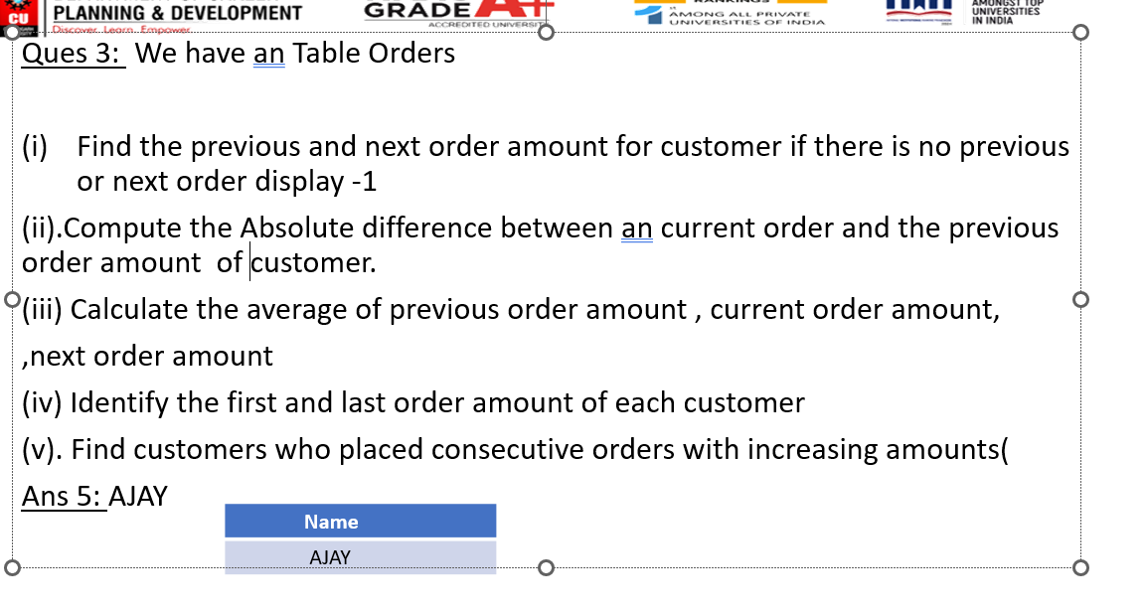

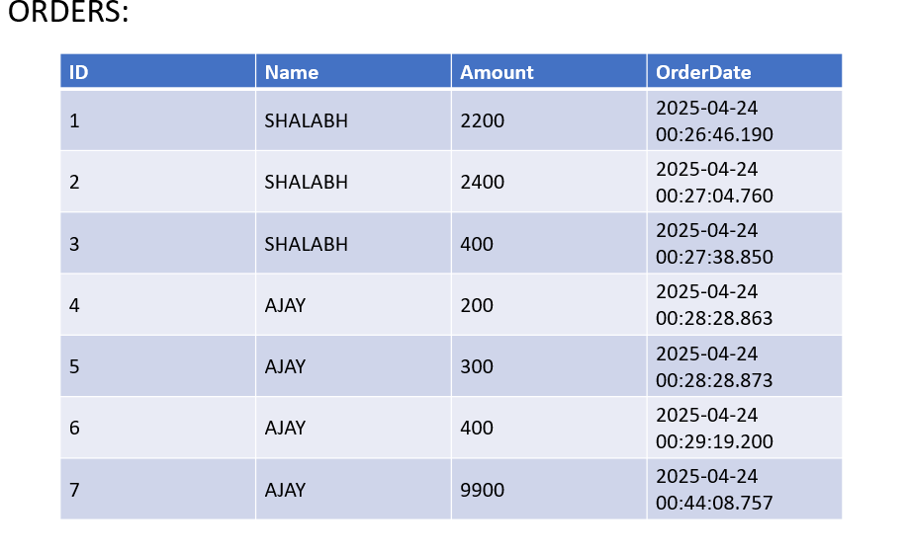

Q4:create database temp

use temp

CREATE TABLE Department (

id INT PRIMARY KEY,

dept_name VARCHAR(50)

);

CREATE TABLE Employee (

id INT PRIMARY KEY,

name VARCHAR(50),

salary INT,

departmentId INT,

FOREIGN KEY (departmentId) REFERENCES Department(id)

);

-- Insert into Department table

INSERT INTO Department (id, dept_name) VALUES

(1, 'IT'),

(2, 'Sales');

-- Insert into Employee table

INSERT INTO Employee (id, name, salary, departmentId) VALUES

(1, 'Akash', 85000, 1),

(2, 'Henry', 80000, 2),

(3, 'Samarth', 60000, 2),

(4, 'Max', 90000, 1),

(5, 'Janet', 69000, 1),

(6, 'Vinay', 85000, 1),

(7, 'Willy', 70000, 1);

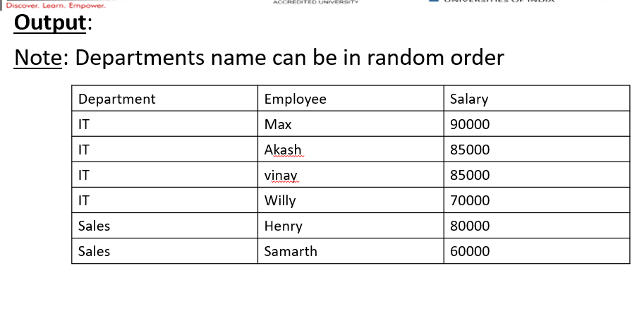

(5)

create database week3

use week3

CREATE TABLE CustomerVisits (

customer_id INT,

name VARCHAR(50),

visited_on DATE,

amount INT

);

INSERT INTO CustomerVisits (customer_id, name, visited_on, amount)

VALUES

(1, 'Jhon', '2019-01-01', 100),

(2, 'Daniel', '2019-01-02', 110),

(3, 'Jade', '2019-01-03', 120),

(4, 'Khaled', '2019-01-04', 130),

(5, 'Winston', '2019-01-05', 110),

(6, 'Elvis', '2019-01-06', 140),

(7, 'Anna', '2019-01-07', 150),

(8, 'Maria', '2019-01-08', 80),

(9, 'Jaze', '2019-01-09', 110),

(1, 'Jhon', '2019-01-10', 130),

(3, 'Jade', '2019-01-10', 150);

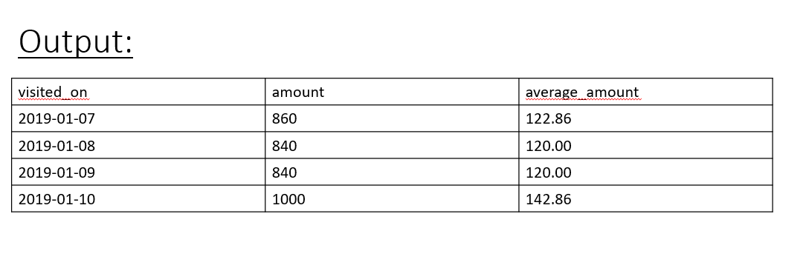

(6)

use q3

CREATE TABLE NTE (

Enrolment_Number INT PRIMARY KEY,

Name VARCHAR(100),

Marks INT

);

INSERT INTO NTE VALUES (1, 'Aman', 88);

INSERT INTO NTE VALUES (2, 'Bhavna', 92);

INSERT INTO NTE VALUES (3, 'Chirag', 75);

INSERT INTO NTE VALUES (4, 'Divya', 89);

INSERT INTO NTE VALUES (5, 'Eshan', 95); -- highest

INSERT INTO NTE VALUES (6, 'Farah', 67);

INSERT INTO NTE VALUES (7, 'Gopal', 84);

INSERT INTO NTE VALUES (8, 'Harshit', 91);

INSERT INTO NTE VALUES (9, 'Ishika', 78);

INSERT INTO NTE VALUES (10, 'Jay', 95); -- highest

INSERT INTO NTE VALUES (11, 'Kiran', 88);

INSERT INTO NTE VALUES (12, 'Lakshay', 82);

INSERT INTO NTE VALUES (13, 'Meena', 95); -- highest

INSERT INTO NTE VALUES (14, 'Naveen', 73);

INSERT INTO NTE VALUES (15, 'Om', 90);

INSERT INTO NTE VALUES (16, 'Pooja', 85);

INSERT INTO NTE VALUES (17, 'Qasim', 86);

INSERT INTO NTE VALUES (18, 'Ritika', 91);

INSERT INTO NTE VALUES (19, 'Sarthak', 89);

INSERT INTO NTE VALUES (20, 'Tina', 80);

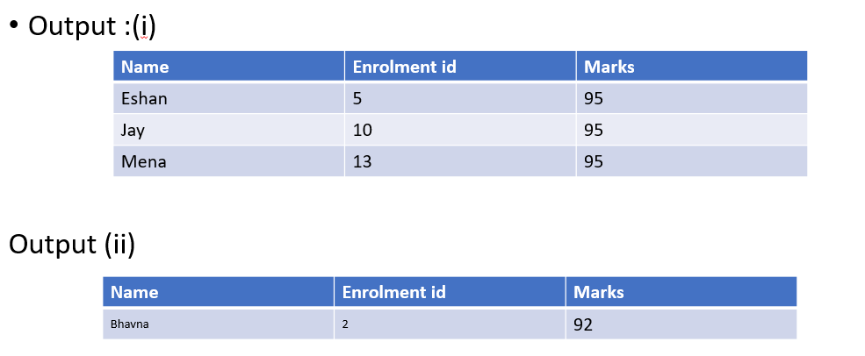

(7)

CREATE TABLE Session_table (

Session_id INT PRIMARY KEY,

Duration INT

);

-- Insert data into the table

INSERT INTO Session_table (Session_id, Duration) VALUES

(1, 30),

(2, 199),

(3, 299),

(4, 580),

(5, 1000);

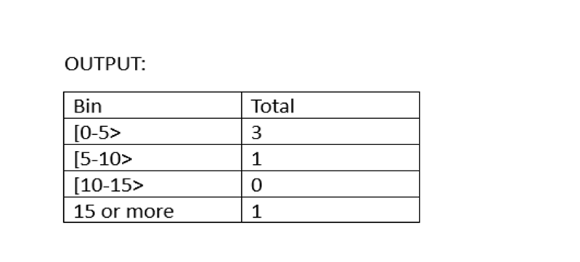

(8)

-- Create the Flight_Seats table

create database q5

use q5

CREATE TABLE Flight_Seats (

SEAT_ID INT PRIMARY KEY,

FREE_SLOT BIT

);

-- Insert the data

INSERT INTO Flight_Seats (SEAT_ID, FREE_SLOT)

VALUES

(1, 1),

(2, 0),

(3, 1),

(4, 0),

(5, 1),

(6, 1),

(7, 1),

(8, 0),

(9, 1),

(10, 1);

**Input Table:**

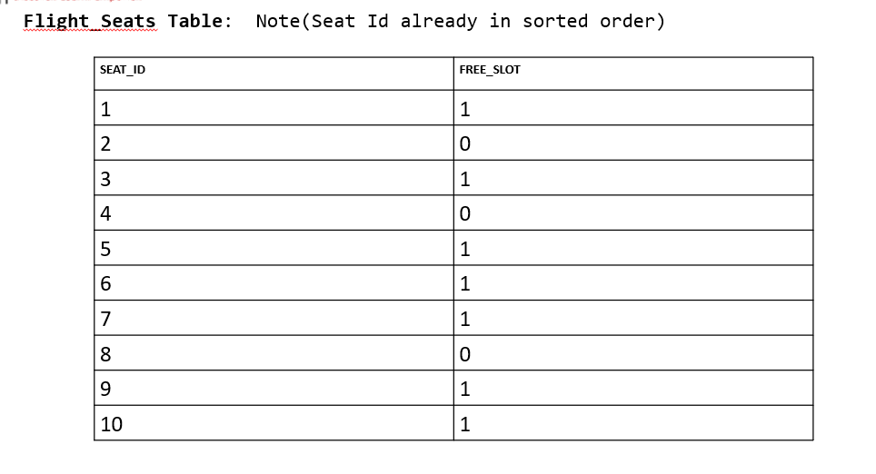

**Output Table**:

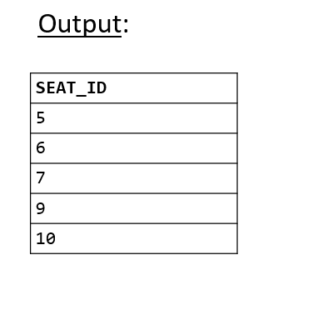

**9:**

use q3

CREATE TABLE RestaurantPersonVisited (

Person VARCHAR(50),

Visited_date DATE

);

INSERT INTO RestaurantPersonVisited (Person, Visited_date) VALUES

('Akash', '2024-04-01'),

('Nisha', '2024-04-01'),

('Nisha', '2024-04-02'),

('Akash', '2024-04-02'),

('Akash', '2024-04-03'),

('Akash', '2024-04-03'),

('Nisha', '2024-04-06')

**10:**

create database imp

use imp

CREATE TABLE Employee (

Id INT,

Month INT,

Salary INT

);

INSERT INTO Employee (Id, Month, Salary) VALUES

(1, 1, 20),

(2, 1, 20),

(1, 2, 30),

(2, 2, 30),

(3, 2, 40),

(1, 3, 40),

(3, 3, 60),

(1, 4, 60),

(3, 4, 70);

**(12)**

-- Step 1: Create the table

CREATE TABLE Account (

account_id INT PRIMARY KEY,

income INT

);

-- Step 2: Insert data into the table

INSERT INTO account (account_id, income) VALUES (1, 10000);

INSERT INTO account (account_id, income) VALUES (2, 18000);

INSERT INTO account (account_id, income) VALUES (3, 60000);

INSERT INTO account (account_id, income) VALUES (4, 70000);

INSERT INTO account (account_id, income) VALUES (5, 55000);

INSERT INTO account (account_id, income) VALUES (6, 80000);

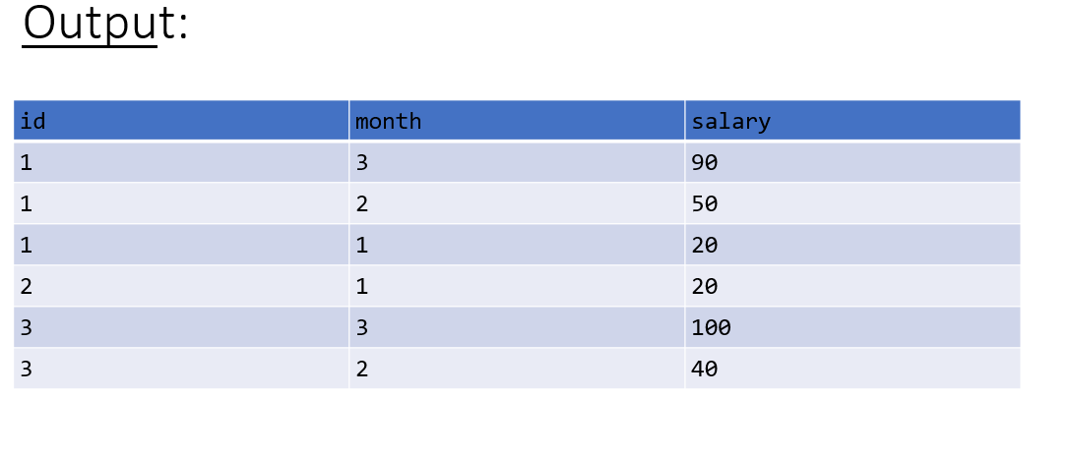

**(13)**

CREATE TABLE Users (

User_id INT PRIMARY KEY,

Username VARCHAR(50)

);

INSERT INTO Users (User_id, Username) VALUES

(1, '_admin'),

(2, 'a_%user'),

(3, 'admin_user'),

(4, 'user_admin'),

(5, '%manager'),

(6, 'a%man'),

(7, 'test_user'),

(8, 'usertest');

**(14)**

CREATE TABLE Employees_orignal (

EmpID INT PRIMARY KEY,

Name VARCHAR(50),

Department VARCHAR(50),

Salary INT,

JoinDate DATE

);

--Source Table

CREATE TABLE Employees_backup (

EmpID INT PRIMARY KEY,

Name VARCHAR(50),

Department VARCHAR(50),

Salary INT,

JoinDate DATE

);

INSERT INTO Employees_backup (EmpID, Name, Department, Salary, JoinDate)

VALUES

(1, 'Alice', 'HR', 50000, '2022-01-15'),

(2, 'Bob', 'IT', 60000, '2021-03-10'),

(3, 'Charlie', 'Finance', 55000, '2020-07-01')

select * from Employees_orignal as e

FULL OUTER JOIN Employees_backup b

on e.EmpID=b.EmpID

select * from Employees_backup

select * from Employees_orignal

(15)

CREATE TABLE Student (

Name VARCHAR(50),

City VARCHAR(50),

Marks INT

);

INSERT INTO Student (Name, City, Marks) VALUES

('Alice', 'Mumbai', 85),

('Alice', 'Mumbai', 90),

('Alice', 'Pune', 75),

('Bob', 'Delhi', 78),

('Bob', 'Delhi', 82),

('Bob', 'Kolkata', 88),

('Charlie', 'Delhi', 70),

('Charlie', 'Delhi', 60),

('David', 'Pune', 80),

('David', 'Pune', 85),

('Eve', 'Mumbai', 91),

('Eve', 'Pune', 89);

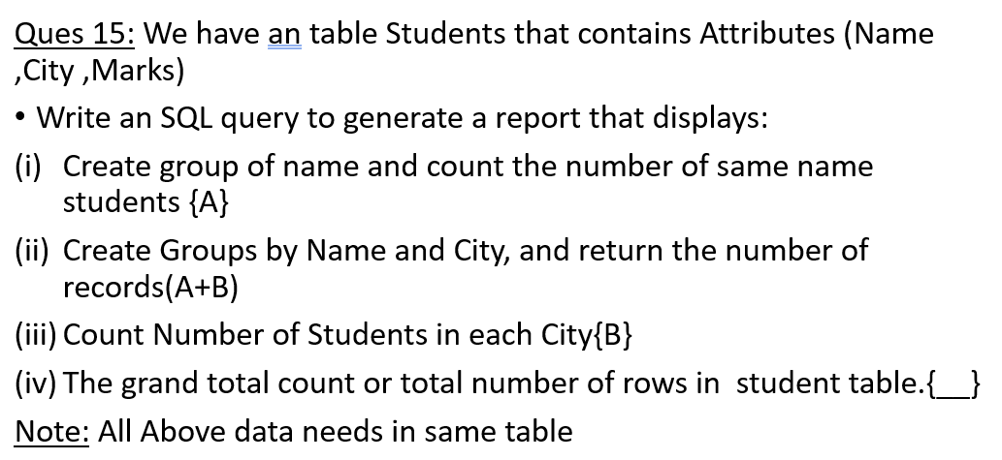

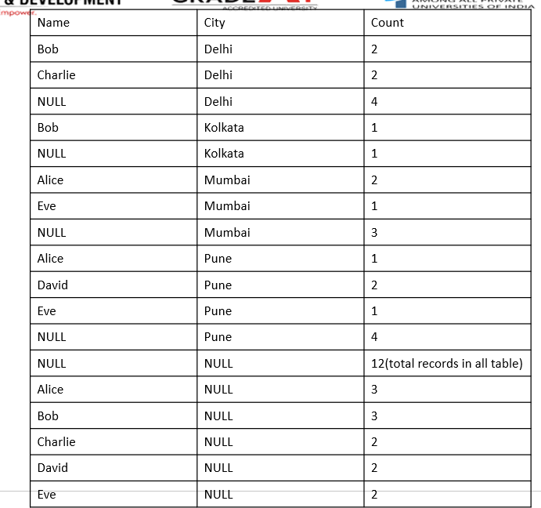

**(16)**

-- Step 1: Create the table

CREATE TABLE Ads (

Ad_id INT,

User_id INT,

Action VARCHAR(20)

);

**-- Step 2: Insert the data**

INSERT INTO Ads (Ad_id, User_id, Action) VALUES (1, 1, 'Clicked');

INSERT INTO Ads (Ad_id, User_id, Action) VALUES (2, 2, 'Clicked');

INSERT INTO Ads (Ad_id, User_id, Action) VALUES (3, 3, 'Viewed');

INSERT INTO Ads (Ad_id, User_id, Action) VALUES (5, 5, 'Ignored');

INSERT INTO Ads (Ad_id, User_id, Action) VALUES (1, 7, 'Ignored');

INSERT INTO Ads (Ad_id, User_id, Action) VALUES (2, 7, 'Viewed');

INSERT INTO Ads (Ad_id, User_id, Action) VALUES (3, 5, 'Clicked');

INSERT INTO Ads (Ad_id, User_id, Action) VALUES (1, 4, 'Viewed');

INSERT INTO Ads (Ad_id, User_id, Action) VALUES (2, 11, 'Viewed');

INSERT INTO Ads (Ad_id, User_id, Action) VALUES (1, 2, 'Clicked');

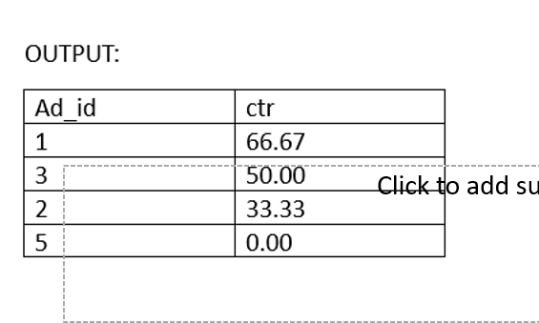

**Q:13**

**CREATE TABLE Users (**

**User_id INT PRIMARY KEY,**

**Username VARCHAR(50)**

**);**

**INSERT INTO Users (User_id, Username) VALUES**

**(1, '_admin'),**

**(2, 'a_%user'),**

**(3, 'admin_user'),**

**(4, 'user_admin'),**

**(5, '%manager'),**

**(6, 'a%man'),**

**(7, 'test_user'),**

**(8, 'usertest');**

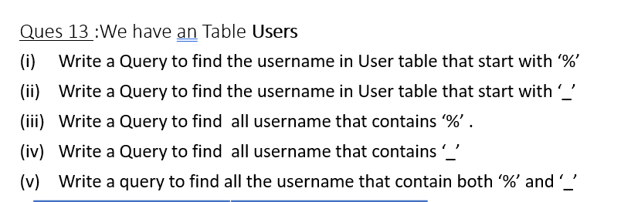

**use q3**

**CREATE TABLE Employees_orignal (**

**EmpID INT PRIMARY KEY,**

**Name VARCHAR(50),**

**Department VARCHAR(50),**

**Salary INT,**

**JoinDate DATE**

**);**

**--Source Table**

**CREATE TABLE Employees_backup (**

**EmpID INT PRIMARY KEY,**

**Name VARCHAR(50),**

**Department VARCHAR(50),**

**Salary INT,**

**JoinDate DATE**

**);**

**INSERT INTO Employees_backup (EmpID, Name, Department, Salary, JoinDate)**

**VALUES**

**(1, 'Alice', 'HR', 50000, '2022-01-15'),**

**(2, 'Bob', 'IT', 60000, '2021-03-10'),**

**(3, 'Charlie', 'Finance', 55000, '2020-07-01')**

**select * from Employees_backup**

**select * from Employees_orignal**

**STORED PROCEDURE**

**QUES 1:**

CREATE TABLE Employees (

emp_id INT IDENTITY(1,1) PRIMARY KEY,

emp_name VARCHAR(100),

salary DECIMAL(10,2),

joining_date DATE

);

INSERT INTO Employees (emp_name, salary, joining_date) VALUES

('Alice', 50000.00, '2023-01-01'),

('Bob', 60000.00, '2023-03-15');